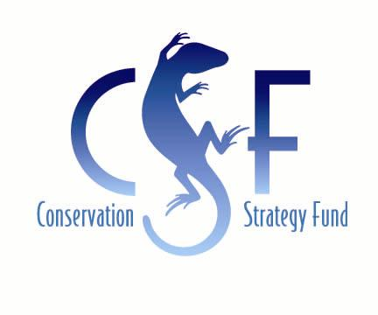


Economic Tools for Conservation
Training for Environmental Professionals

Conservation Strategy Fund is now accepting applications for its annual international training course Economic Tools for Conservation at Stanford University. During the two-week course, participants will learn to use economics to be more strategic and successful in their conservation work. Participants will study natural resource and environmental economics, practice communication and negotiation techniques, and get hands-on experience with cost-benefit analysis. This course is presented in partnership with the Center for Conservation Biology at Stanford University and Conservation International.
Training Dates
August 20 - 31, 2007

Location
Stanford University, California, USA

Application Deadline
April 16, 2007

Final Participant Selection
May 7, 2007

APPLY NOW

Participants
This course is for people at the forefront of conservation challenges in high-biodiversity developing countries, including managers of conservation programs and protected areas, directors of non-governmental organizations, and representatives of public environmental agencies. Applicants from a variety of disciplines such as biology, forestry, law, anthropology, or economics are encouraged to apply. Previous training in economics is beneficial, but not essential. Applicants must be proficient in English.

Outcomes
Participants will gain the following:

- A working knowledge of economic methods, language, and concepts as applied to the environment and natural resources
- The ability to articulate environmental values, identify problems and objectives in economic terms, and evaluate costs and benefits of natural resource management decisions
- Skills in communication and negotiation

Program
The course covers the following subjects:

- Microeconomics
Market theory: supply, demand, market equilibrium, and competition.

- Natural Resource Economics
Capital theory
Renewable and non-renewable resource extraction, markets, and policy trends.

- Environmental Economics
Why markets are inefficient when it comes to environmental protection.
How economists place monetary values on the environment, and how these methods are best used in developing countries. Identifying opportunities and barriers for payments for environmental services.

- Negotiation and Simulation Exercises
Exercises and instruction focused on policy negotiation skills.

- Cost-benefit Analysis
Case studies evaluating the economic feasibility of small-scale and large-scale projects, including incorporation of externalities and sensitivity analysis.

- Communication
Effective strategies for presenting economic analysis results.
Details
Location
The course will be held on the Stanford University campus in Stanford, California. Situated in the heart of Silicon Valley, Stanford is 25 miles from San Francisco and close to downtown Palo Alto. The beautiful 8,000-acre campus is surrounded by rolling oak woodlands and provides numerous opportunities for outdoor recreation. All course activities will take place at Stanford, with field trips planned in the surrounding area.


Instructors
Economic Tools for Ecosystem Conservation is taught by experts in environmental economics who also have extensive field experience and understand real-world conservation challenges. They are drawn from several leading academic and international institutions including Stanford University, Harvard University, INCAE, the World Bank, and the University of California at Los Angeles. Additional instruction is delivered by CSF staff.

Cost
The cost for the course is $3,000 per participant. The tuition fee covers all meals, lodging, field trips and course supplies, but does not include transportation to Stanford University. All participants must cover their own travel expenses to and from the course site.

Follow-up
CSF believes that learning merely starts in the classroom, and should continue in the field. For this reason, we often provide technical assistance through our Groundwork Program to help course graduates to apply their new skills to conservation challenges in their home countries. This follow-up assistance is dependent on the availability of funds, the quality of participants' project ideas, and their capacity to lead implementation in the field.

How to Apply
If you would like to apply for this course, please fill out the application. All application materials must be received by April 16, 2007. We encourage you to submit your application materials as soon as possible because we will make admission decisions on a rolling basis. Please consult www.conservation-strategy.org for more information on Conservation Strategy Fund and our courses and analysis projects.

